# Vehicle Loan Defaulter

# Software Used:

**Python, Tableau**

## Data Preliminary analysis:

1. Dealing with **missing data:**

The only column that has missing values is **employment_type** with 7661 missing values

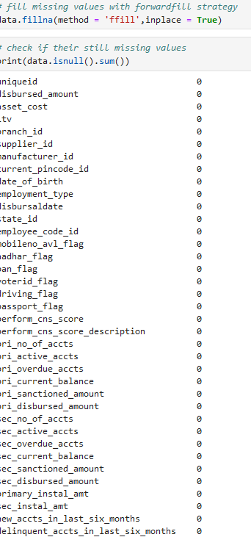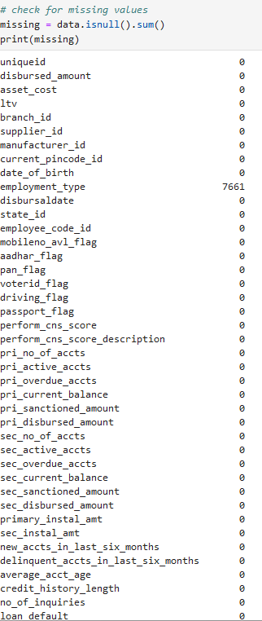

1. Dealing with **duplicates**:

No duplicate found

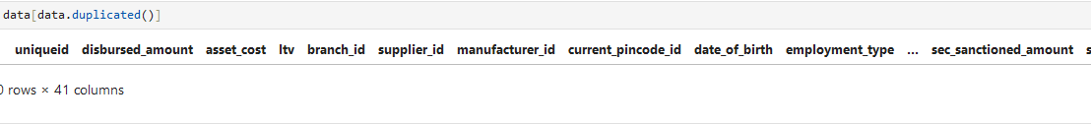

1. **Data Summary**

Analysis:

In loan_default mean approximately **0.217**, suggesting that about 21.7% of the loans are in default. This is a critical metric for assessing risk.

the low levels of overdue accounts(sec_overdue_accts) **mean of 0.0072** and delinquencies (delinquent_accts_in_last_six_months) **mean of 0.097** indicate that many borrowers maintain good financial health

1. **Loan Default** Distribution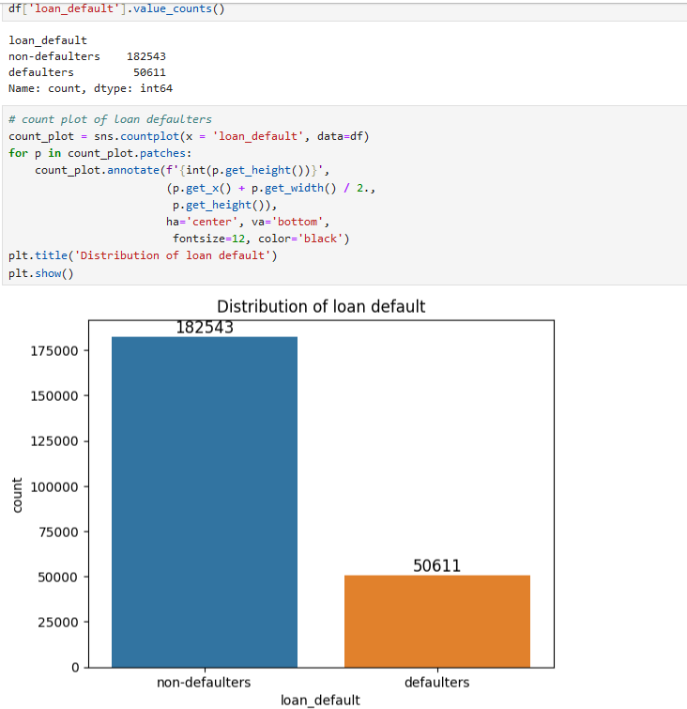

Analysis:

Customers with **No loan defaults (182543)** is more than customers that has **loan default (50611)**

1. **Count plot of Employment Distribution**

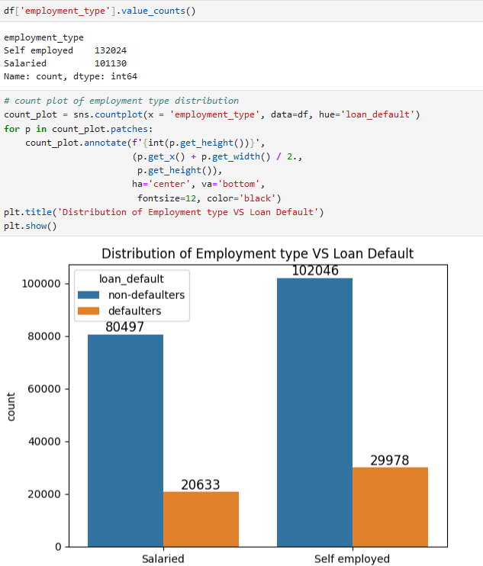

Analysis:

Selft employed an salaried loan defaults are **slightly the same.**

1. **Age Distribution Vs Loan Defaulters**

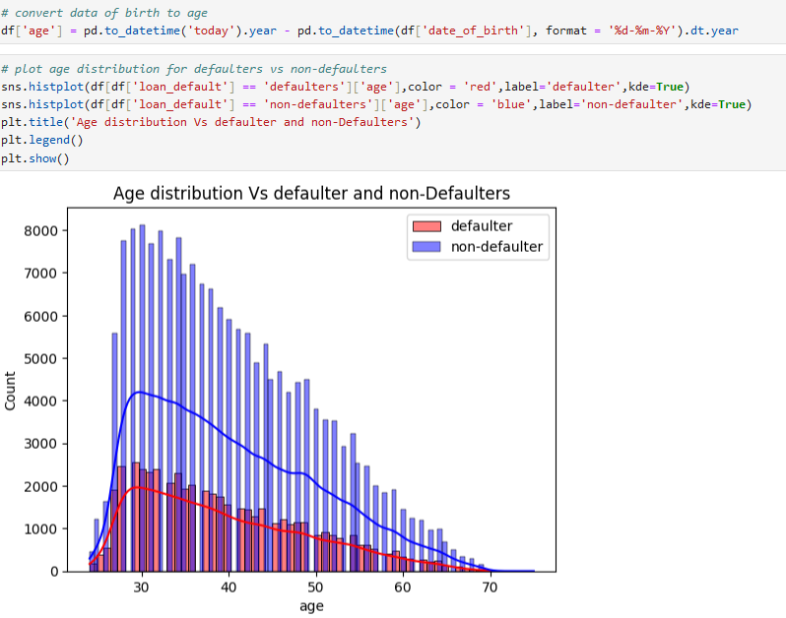

Analysis:

Most of the loan defaulters are in the **age range (30-40)**

1. **Credit Bureau Vs Loan Defaulters**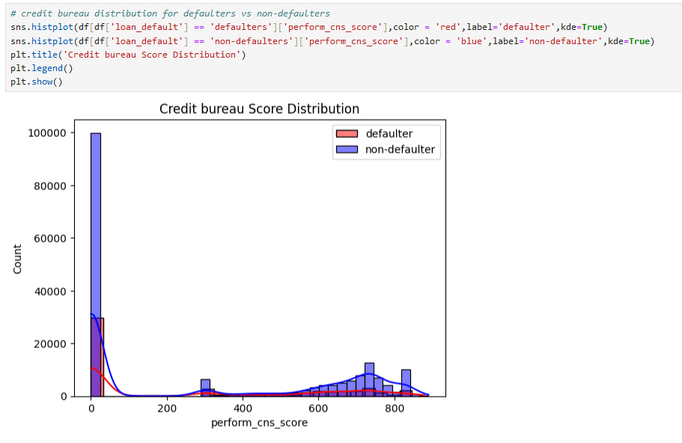

Analysis:

The lower the **Credit Score** the **lower the loan defaulters number.**

1. **Loan Default Rate by State** 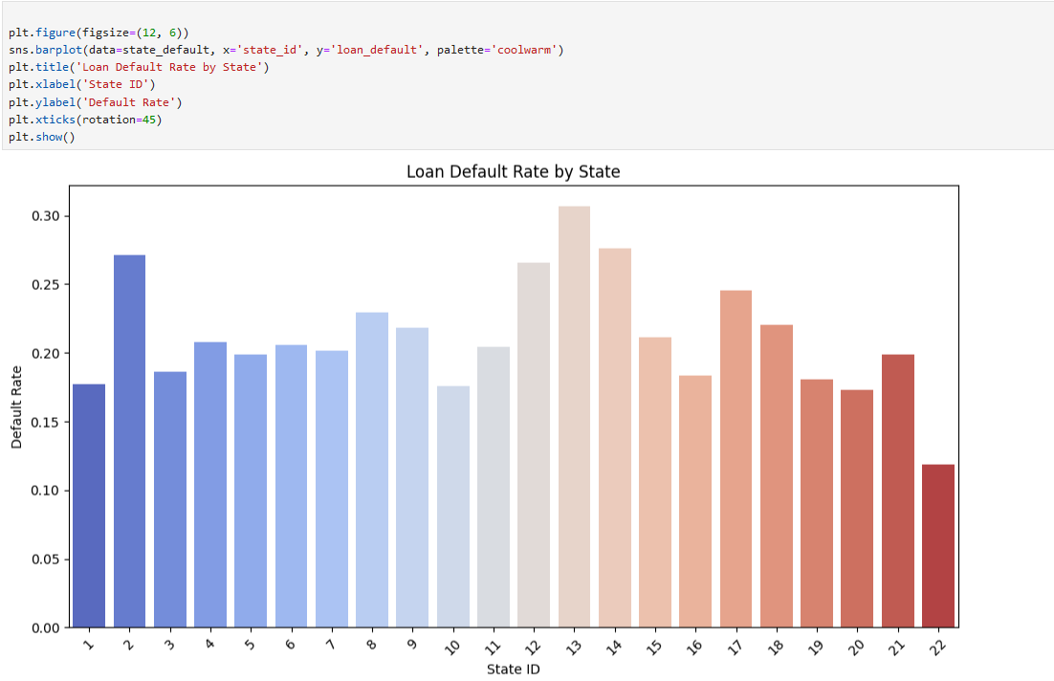

Analysis:

**State 13** has the highest rate of **loan default (30.66%)**

1. **Manufacturer Rate by Loan Default**

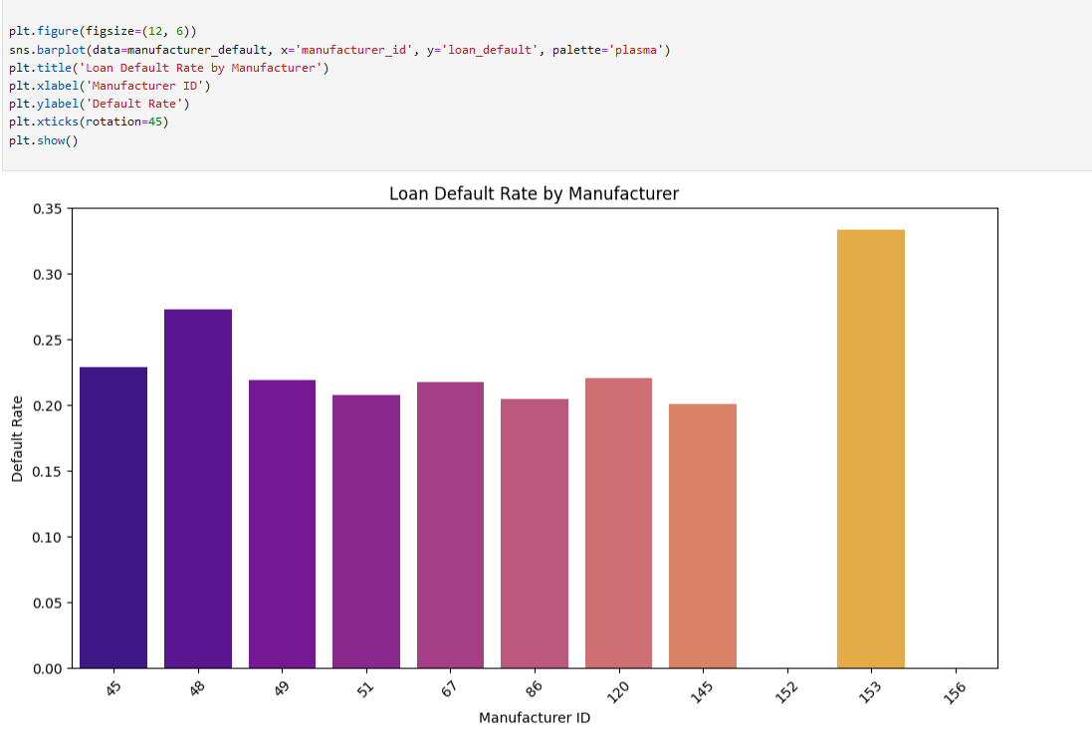

Analysis:

**manufacturer_id** 153 has the highest loan default rate at **33.33%**. This suggests a higher risk of loan defaults among borrowers who purchase products from this manufacturer.

1. **Loan Defaulter Rate by Number of Inquires.** 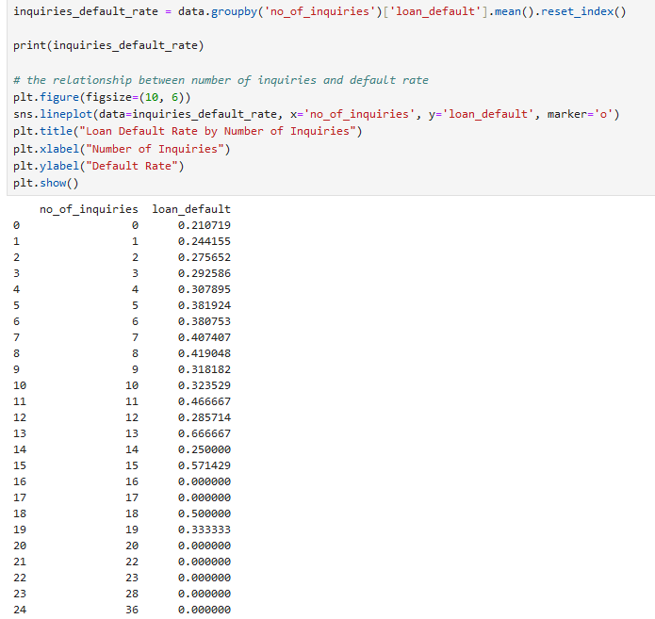

**Analysis**

**customers with around 11 or fewer inquiries tend to have a higher risk of loan defaults. However, this trend becomes less clear with more inquiries**

1. **Relationship between target variable and other Variables**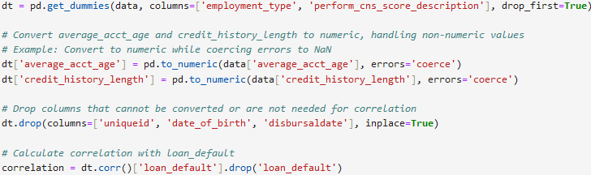

Analysis:

*Positive Correlations:*

**Delinquent Accounts (Last 6 Months)**: A small increase in recent delinquencies is linked to a higher chance of default.

**Number of Inquiries:** More loan inquiries may slightly raise the risk of default.

*Negative Correlations:*

**Perform CNS Score**: A lower credit score is related to a higher risk of default. Better credit scores mean a lower chance of default.

**Primary Active Accounts:** Having more active loans might lower the risk of default.

Age: Older customers tend to have a lower probability of defaulting.

*Low Impact Factors:*

Factors like loan amount, asset cost, and loan-to-value ratios show weak correlations with default risk, indicating they have little effect.

1. **Regression Analysis**

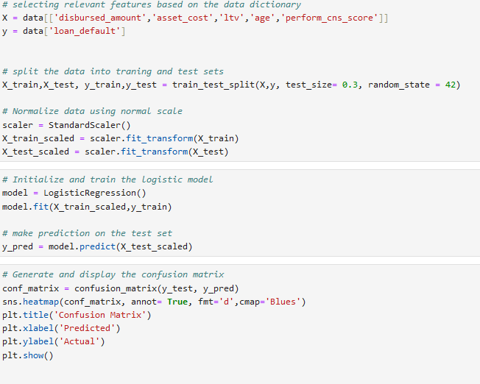

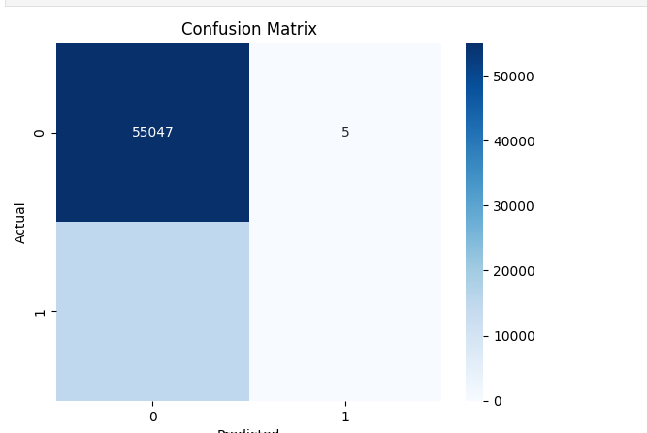

Analysis:

**The regression model** shows accuracy **of 79%**

1. **Dashboard**

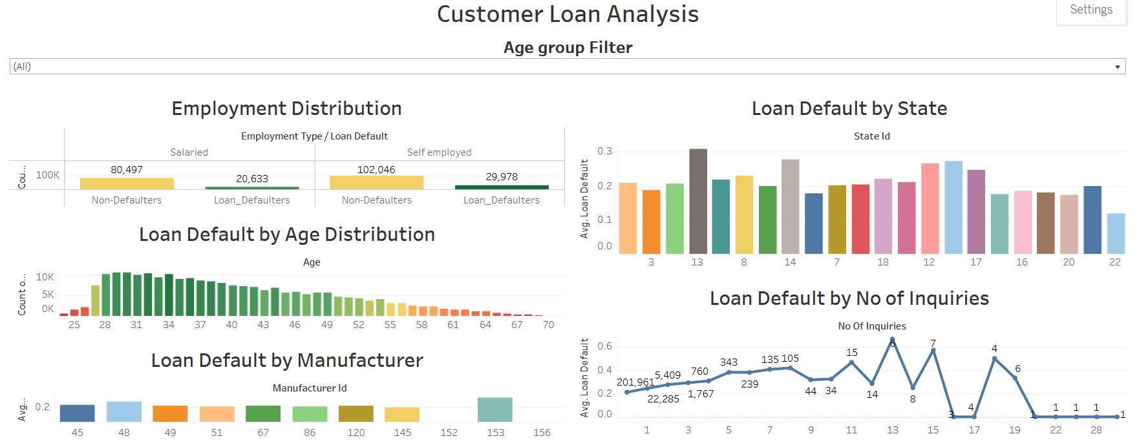

## Key Insights

• **Model Effectiveness**: The regression model has an accuracy of **79%**, meaning it effectively predicts which customers might default on loans. This helps lenders make better decisions.

• **Loan Inquiries and Default Risk**: Customers with **11 or fewer loan inquiries** are more likely to default. This suggests that a low number of inquiries could indicate financial trouble. Lenders should consider this factor in their risk assessments.

• **Manufacturer Risk**: Loans from **manufacturer_id 153** have a **33.33% default rate**, the highest among all manufacturers. This points to potential issues with products from this manufacturer, and lenders may need to review their lending practices for these borrowers.

• **Geographic Variability**: **State 13** has a **30.66%** loan default rate, showing that local economic conditions greatly impact loan performance. Lenders should take these factors into account when creating lending policies, particularly in high-risk areas.

• **Demographic Trends**: Most loan defaulters are aged **30-40**, a group that may have unique financial pressures. Understanding these challenges can help lenders develop tailored products and support for this demographic.